Branching and Merging Code with Git Source
Control SOP



Table of Contents

1. Branching and Merging Code with Git Source Control 3
1.1 Description 3
1.2 Architecture Diagram 3
1.3 Lab Steps 4
1.4 Troubleshooting 5
1.5 Supporting References 5

Branching and Merging Code with Git Source Control

Description
When using Git for source control and versioning, the ability to branch a repository while you make changes off the mainline is key. However, eventually, that branch will need to re-join the master branch and you will need to perform a merge. This is how a single Code Base is used to perform multiple developmental activities.

Architecture Diagram
The diagram below displays a visual representation of the application architecture:
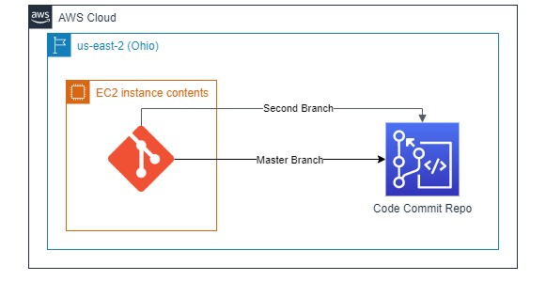

Lab Steps
Follow the steps outlined below to achieve the objective of this lab exercise:

- Create a CodeCommit Repository.
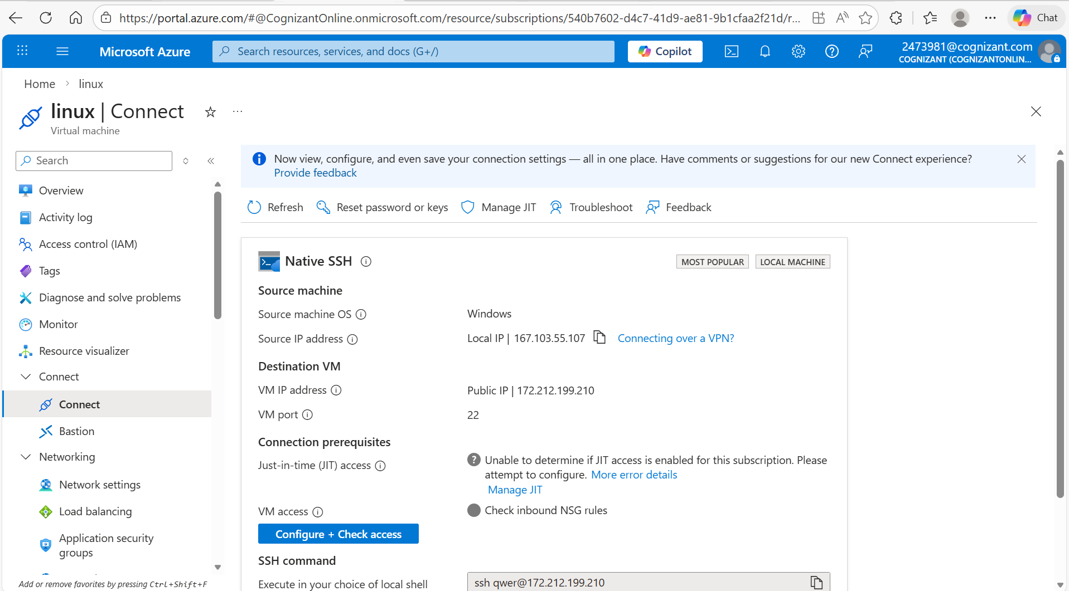
- Create an EC2 Instance (Amazon Linux 2) and SSH into it using the Sessions Manager Option. Note: Make sure CCL-EC2-Role is attached to the instance, only then SSH is possible with Sessions Manager Option.
  - Use the command to install git:
sudo su
sudo yum install git –y
  - Install AWS CLI (Refer the third link in Supporting References section).
  - Use aws configure after installing and set region to us-east-2. Press enter for rest of the options. d. Install Unzip (install if needed).
- Configure the system with the user email and user name:
git config --global user.email <some sample mail ID> git config --global user.name <some name>
- Navigate to IAM > Users > Your UserName > Security Credentials > HTTPS Git Credentials for CodeCommit. Here generate credentials and save them.
- Clone the CodeCommit repository using the git clone command which can be found in Step 3 under Connection Steps in created repository.
- Go to the repo folder:
cd <destination path>
- Create some text file with some content in the folder.
- Now give the following commands to push the file to the repository:
git add <filename>
git commit –m “Some Commit Message for reference”
git push
Note: The git push command pushes the code by default to Master Branch.
- Verify if the file is reflected in the Code commit Console Page.
- Create a new branch:
git branch <some branch name>
- Switch to new branch with command:
sudo git checkout <branch-name>
- Create some file in the newly created branch.
- Using the following command, find the untracked files and changes made in the files.
git status

- Commit all the changes:
git add <filename>
git commit –m “<Some Message>”
git push --set-upstream origin <branchname>
- Check in CodeCommit if the newly created branch is available there.
- Switch to master branch from current branch using the following command:
checkout
- Execute the following command to merge the branches:
aws codecommit merge-branches-by-fast-forward --source-commit-specifier <branchname> --destination-commit-specifier master --repository-name <repo-name>
- Check the CodeCommit page to see if both the files are available in the master.

Troubleshooting
S. No | Problem | Solution
1 | Git command not found in your terminal | Make sure git is installed:  sudo yum install git
2 | Branch not found | Give branch name correctly while checkout to that branch.

Supporting References
Refer the below links for additional information:

- https://git-scm.com/book/en/v2/Git-Branching-Basic-Branching-and-Merging
- https://www.atlassian.com/git/tutorials/using-branches
- https://docs.aws.amazon.com/cli/latest/userguide/install-cliv2-linux.html
